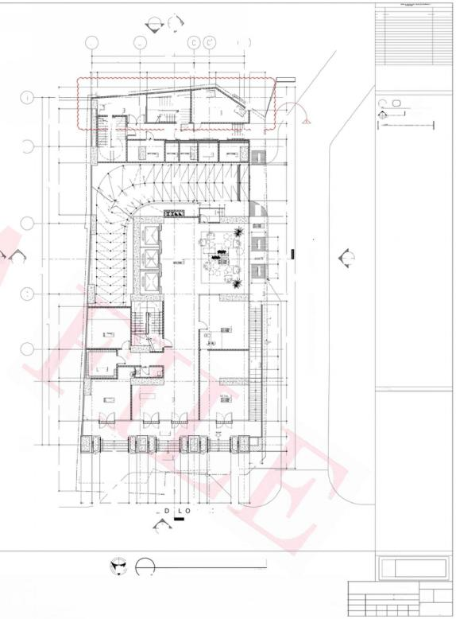
DRAWING REGISTRY
DESCRIPTION
MARK
个
DATE

DEC.10,2024
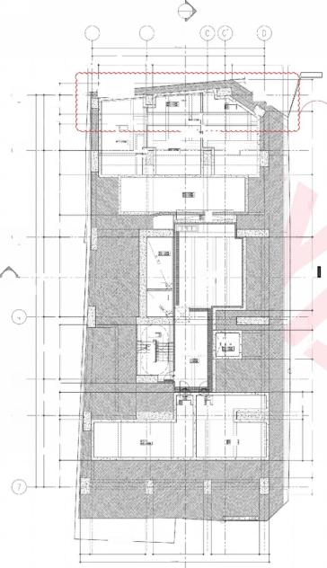
WRTENDIMENSIONSONTHESEDRAWINGSSHALHAVEPRECEDENCEOVERSCALEDLLAT.SY TM(ARCHITECTURAEaCHNICAL,ETCusReAN2oNAuL.,5TRUC)SHALLTURAL,BESUBECToaosa5ANITARY,ELECTRICALFORVERIFICATIONsecnano0s,
SEESECTIONB
8920 5695
4137 2483 2715 000 1980 1205
6500 3260
6437
2300
40315
7350 3750 6400 8200
4200 400 2385 96540Q 5600 800 8200
.
ERTY LINE
4235 800 2035
7070 3359 3000 2019 7540
dOdd
2750
1700 1765
SEE SECTION'B'
5695
1900 4695 1000293 1200
面
(5
2% SLOPE
2750 1800 90 2655
40315
7350 3750 6400 8200 8920
5355 2750 4600 3350 4950 1450 6020
000l
1% SLOPE
1%S0H3了
975
009
dUNE OF BUILDINGABOVE
SLOP 12% SOFE
PROPER
制土
1500 650 1500 1650
0009 0009
800 1800 4200
4200 800 8950
44265
0028
A B R A
2000 1700 1800
穆④
页⑥
a G N 气
慌 S O F E D
供 S 0
新
飞
S
E
/
0
四⑤⑩
②①
①@0
EN
T
S
INCLINED COLUMNADJUSTMENT
2
A-501
A
1402
0
A B
17720
I
6250
5615
1815 4036
744 2745 547650 1787
798
4965
800
5050
440
REF.ELEVATION ±00
PROPERTY LINE
LEGEND:
①
四1791
1
MERALCO iACCESS
DRAWING NO.
SHEET NO.
SHEET TYPE(A/ME/P/FP/S)
oO⑨①STAIR
⑧⑥⑤④⑤②0
uP-
一BLOWER ROQM
FCC/SEC ROOM
般
⑩
CUITTING LUNE
o r 阿
示 ① (
MAICH LINE
世
拾
食
⑤o③②o
二
「R RU 二
「RUD 二
(2
P ④
③
EE ROOM
WET
SPECIAL
◆HL=100w
◆SSL=9500M
DRY
SL-950M
REC
52=950W
F.E/1
552=100W
SSL=950MN
席SOPE

1150
博 5OPE
13 SOPE
dLNE Of FIRE RESERVE TANK BELOW
euP
段
%SLOPE
3
SLP
1600
A
2402
SEE
SECTION'A'
E4 LEVATOR LOBBY
TL=1000N
A
2|40y
1
A-501
cf-ur
DRAN
量
1600
SEX1
4
摄
1360
RAMg uP
I|
⑩ ⑨
PROWSON FOR STORAGE
⑥ ⑤ ④ ③
>
RETAIL 3
ADMIN
52=950W
面
D:回
u
P
F
2
5
LANDING
M AIL
ROOM
coMMON TOLET
=9dm :
Poo Toue
O
66
KEYPLAN:
LOBBY
中FfL=1000WM
SSL=950M
RETAIL 1
L=950W
8.
ARCADE
-90n
⑦
4
1450
duNE oF BULDING ABOVE PROPERTY
nE
1
dLNE GF EULDING POE
dBROPERTY LNE
900 3400 900 N A T I V
DROP OFF AREA
2750 900
Z S T.
300 900 2905 900
I D A
900
E
13po
1250
13bo
P
2
A-501

A
17720
6250 1815 4036
700 5650 714 3322 1936 500
REF.ELEVATION ±00
peoeer
PROPFRKY
ASD ANOXIC
TANK L/NF
65
C A W L jK
-160
S E w N E
(VERIFYTINON FbwRATE)
SBR-TTANK
-SBR-2-ANK-
WATER.DEP504500 MM.- WATER DEPTH 三 4 5 0 0 _MM
BELOM

FIRE RESSERVE TANk

3

0
品
SEE

SUMP_ PIT

SUMP_ PIT

2
3B0MW
cOMMERMCIAL
P[u MBIN G PψMP ROOM
I
UP
⑤

6

CISTERNl
iANK1

dPROPERTY LINE
1000 5705 800 5200 800 4950 10po
19455
1 SECTION'A' A-501
IEMPOCTOIO
婴
.E.±5000_MM.
S8=-6750M 65N
EQUIPMENT ROOM 50
①
EQT TANK BELOW
S5=-6750W
②
CISTI ERN TANK 2
397700
BSCFN
B
4865
5615
K

4

DRAWING PHASE:
S

3十
N
N
1 SUBSTRUCTURE
SCALE:
FL ○OR PLAN
1:100 M
s
CROUND
M
FLOOR
PLAN
1:100 M
2
A 301
FOR CONSTRUCTION BULLETIN
ASYA ASYA
升m
3十
SCALE:
A 30
N
ASYA
N

SHEET NO.
A 301
TOTAL SHEETS
173
SUBSTRUCTURE &GROUND FLOOR PLAN
MAR 2024 SCALE AS SHOWN PROJ# GRF
ER T T T T T
ER
△SYA | SEAL NOTE DESIGNER  THIS DRAWING ACTING AS AN WRITTEN DIMENSIONS ON THESE DRAWINGS SHALL HAVE PRECEDENCE ALLAN C.CHUA  REPUBLIC ACT 9266  PSTPURENOF ASYA SESIGC PARINERRE.SPONSIBLE FOR ALL DIMENSIONS AND CONDITIONS ON THE JOB.THE  OVER SCALED DIMENSIONS.CONTRACTORS SHALL VERIFY AND BE |  |  |  |  | STRUCTURAL E  Jct | NGINEER  ROBERT CHRISTOPHERA.NIEBRE | SANITARY ENGINEER  JUAN CARLO NORBERTE S | FIRE PRO ENGINEER  WI L FRED ABROGENA | ELECTRICAL ENGINEER  STEPHEN NAPEŇAS | MECHANICAL ENGINEER  WILFRED ABROGENA | PROJECT TITLE AND LOCATION | LAND OWNER &DEVELOPER | SHEET  CONTENT
APLAGCE ASIA CGMPLeR,CBP-YA 72/85-05  EMAlL ADD.asyo@usyadeslgn.com.ph | DuSsucn MEpF  SAID DOCUMENTS FOR USE IN THE REPETITION OF AND FOR OTHER PARILECTSRIN WHDLEWTHou CHER CONSENT.ALL DRAWINGS ARE TO BE RETURNED WHEN NO LONGER IN USE. | DESIGNER MUST BE NOTIFIED IMMEDIATELY OF ANY VARIATIONS FROM THE DIMENSIONS AND CONDITIONS SHOWN BY THESE DRAWINGS.  ANY DISCREPANCY ON ALL DRAWING &SPECIFICATIONS  (ARCHITECTURAL,STRUCTURAL,SANITARY,ELECTRICAL &MECHANICAL) SHALL_BE SUBJECT FOR VERIFICATION AT THE ARCHITECT's OFFICE BEFORE IMPLEMENTATION. | REG.NO:0023165  PTR.NO:8453438 | ARCHITECT  TIN:  DATE: | 289-222-941  01-03-2024 | 2302C East Tower PSE Certre,Echong od otos cco24010 a iroeqnoutoon | STRUCTURALENGINEER e  REG.NO.011903 TIN 273548-50 PTR NO.1007400 DATE 01-0424 PLACE MAKATICITY | SANITARY ENGINEER  0REG.NO:0002835 TIN: 319-240-799  PTR.NO:8453437 DATE: 01-03-2024 | MECHANICAL ENGINEER  REG.NO:0004781 TIN: 215-380-265  PTR.NO:8453436 DATE: 01-03-2024 | ELECTRICAL ENGINEER  REG.NO:0004290 TIN: 242-781-694  PTR.NO:8453439 DATE: 01-03-2024 | MECHANICAL ENGINEER  REG.NO:0004781 TIN: 215-380-265  PTR.NO:8453436 DATE: 01-03-2024 | GALE RIES TOWER MANILA  NATIVIDAD LOPEZ STREET COR.CABRAL STREET,MANILA | GRAND TAIPAN LAND DEVELOPMENT,INC. | CADD  CHECKED
 |  |  |  |  |  |  |  |  |  |  |  |  |  | APPROVE
DATE D

I 192.168.2.203\production-othersOthers-Galeries\011 EDIT FILE\100%FCD Plans\03 AR FCD\CADA-300 Floor Plans\301 Substructure &Ground Floor Plan-FOR CB001.dwg

 | DRAWING REGISTRY
MARK | DESCRIPTION | DATE
个 INCLINEDCOLUMNADJUSTMENT 10,2024
DEC.

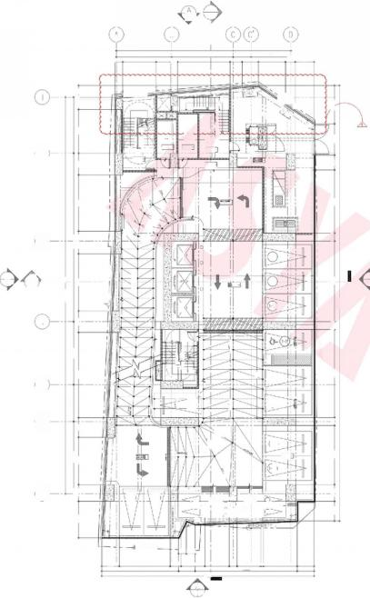
ANDcONDITDIMENSIONSDSATIONSONSONTHEJOBcONTRACTORSPRECEOVERTHESHALLVERIFYDESIGNERSCALEDANDcONDANDMUSTBEBERESPONSIBLENOTIFIEDIMMFOITIONSSHOWNBYTREHESEDALLIATELYDIMENOFSIONSANYDRAWINGS. TM(ARCHITECTURAECHNICAL,ETCausReAN2oNAuL.,5TRUC)SHALLTURAL,BESUBECToaosa5ANITARY,ELECTRICALFORVERIFICATIONsecnano0s,
SEESECTION8
5695
2288 5733 2187 4451 100025 1193
SLOPE
博下0FE口
BLEND-
1第S0
1217
RMP 102NOF00
800 6420 1497 3200 3888
40315
7350 3750 6400
4809 8660 2139 582
N7
ROPERTY
19.50%
SLOPE
幼三3d07S
SLOPE
幼三30S
w飞QE
S0PE
8200
44265
PROPERTY LINE
800 8950
0009
3700 1f0o
A
2000 1410
2
1402 A-501

B

17720
6250 I
5325
700。

PROPERTY LIN
PRORERTY
户C
◎⑩ ⑩ 起 延 延 ①
TRANSFORMER
ROOM
2
道
霞
FF
MERALCO ACCE$S
◆HL-55DOWN 882-56n
F.E.
中 L=5500MM
55L-5500W
般

长

+SSL=550WM
18 SLOPEE

18 SLOPED
1 SLOPEc
RAMP UP
1 SLOPEE
③
Pe 1-01

4150 920
DROF-OFF
1-02-
A-501
O
-03)
O
4

g 调
⑨ ⑩2|①
中 =6411M
+SSL=6361M
1-04

1-05
6
1席 SOPE
060
摄
0

1200MM HIGH PARAPET WAL
1-03
MOTORCYCLE
PARKING SLOT

INE

ROPERTYLINE
805 880
1110 2400 2490 80o 2400 259 3441 1710 1685 10358 1710
21551
A
1 401
1815 4036
h238 1645 2746 95 1911
⑦
01
MOTORCYCLE PARKING SLOT
5615
3387 1478
RoO0M
◆FL=5650WN 5L=5600N
⑩ 面⑧①⑥ ④ ⑤②①
②
⑩ ⑩ 0
透 ⑩
② .
⑤
10
A
2 401
A 2402
ROOM
◆FL=5650MM
◆SSL=5600W
160po
B
BICYCLE RACK
书
再
②③④粤 ⑥
A O
00
SECTION'A
530
RAMP UP FROM GRORUND FL00R
通 面

⑤
② 品
0298
1 SOPE
1772
SEE
798
STAIR
o
1
7798
5169
F. .E.
04
人
丝
0
SLOPE ·
A
2
l
L.

A
2402

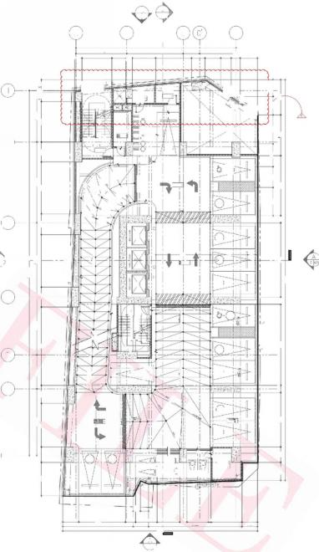
SEE SECTION8
5695
2197 4470 203
000
209
3888
2527 3200
507
8920
2298 5723
40315
7350 3750 6400 8200
4800 2000 865 2199 5802
00L2
N 行
编50FE
博飞0FE
iL0
体乳0FE
SLOPE 11.01%
PARAPET WALL
体SIo元
RAAP UP T03RD FL0OR
1g90t
SLOPE= 4% SLOPE= 4%
NOPAPKNG
3100 2300
8200 6620
44265
P R O P E R T 人
2000 1700 6000 800 8950
LEGEND:
① DRAWING NO.
四1791 SHEET NO.
SHEET TYPE(A/ME/PFP/S)
CUTTING LINE
MATCHLNE
KEYPLAN:
A
1402

B

17720
6250 I
2600 ↓700

IN
STORAGE
.
◆FL=8800MM
◆fL=8950WN
HL8900W

MNNMNMNMMI
Q
⑥
05
EE
ROOM
89560
UP
10
20
(214)
Q
X
1第 SLOPEL

2-02
sLoPE
13 SOPE
R8

P大
2-03
O
O
4150
OFF
8

2-05
o
4
品
DN
2-15

=-971MN
◆SL=9661M
2
2-06
2
5

2-07

6
RAMP UP FROW 1sT FL0OR
&OPg
2-08)
开
◆SSL=835DM
2-00

1260 MM HIGH PARAFET WALL
8
T
2-11 2-10
IELCO
2
-
PARKING SLOT
MOTORCYCLE PARKING sLoT
LINE

dPROPERTYLINE
805 880
1772 5169 1110 2400 2490 800 2400 259 3441 1710 7798 1685 10358 1710
2155
A
1 401
临 =3d07S A
5615
3322 1553
②
PROPERTY
06
07BICYCLE
RACK 09
4036
1732 1164
⑦
1
A-501
①r ② ③
⑥ ② ⑧ ⑨
BICYCLE
RACK 3
⑩矿⑧⑦ ④③②①
b 5 5 墙 ①⑫
95 1911
160po
DRO中-
SEE SECTION'A
→ 十 十
AU文 ROOM
中 FRL=8650MM
SSL=8650uu
dPRORERTY
◆FFL=8800MW 55L=8250M
②⑫ 品
华3d07S
5⑩ ⑩ 阿
中十798
MOTORCYCLE
3
A-501
Q
C
BEen
D
ROOM
1815
1495
13 SLOPEE
sE×
A
04
摄
EN
第夏OPE
SSL-8750W
品
3963
(04
(03
1
将

2
EE
920
十
U
素
F.I

DRAWING PHASE:

4 1ST
A 3025CALE
PLAN
FL○OR
M
3
1:100 M
D
AN
1:100 M
N
□ LOOR
2ND
SCALE:
2
A 302
3 M
D

△SYA | SEAL | NOTE | DESIGNER |  | STRUCTURAL E | NGINEER | SANITARY ENGINEER | FIRE PRO ENGINEER |  | ELECTRICAL ENGINEER | MECHANICAL ENGINEER | PROJECT TITLE AND LOCATION | LAND OWNER &DEVELOPER | SHEET  CONTENT
△SYA | REPUBLIC ACT 9266  THIS DRAWING ACTING AS AN  PRSOPEUMENToF ASYA DESYiC PARINER. DuSsucn MEp  SAID DOCUMENTS FOR USE IN THE  REPETITION OF AND FOR OTHER  PARILECTSRIN WHDLEWTHou CHER  CONSENT.ALL DRAWINGS ARE TO BE RETURNED WHEN NO LONGER IN USE. | WRITTEN DIMENSIONS ON THESE DRAWINGS SHALL HAVE PRECEDENCE  OVER SCALED DIMENSIONS.CONTRACTORS SHALL VERIFY AND BE  RESPONSIBLE FOR ALL DIMENSIONS AND CONDITIONS ON THE JOB.THE DESIGNER MUST BE NOTIFIED IMMEDIATELY OF ANY VARIATIONS FROM  THE DIMENSIONS AND CONDITIONS SHOWN BY THESE DRAWINGS. ANY DISCREPANCY ON ALL DRAWING &SPECIFICATIONS  (ARCHITECTURAL,STRUCTURAL,SANITARY,ELECTRICAL &MECHANICAL) | ALLAN C.CHUA  ARCHITECT |  | U cE  2302C East Tower PSE Certre,Echong | ROBERT CHRISTOPHERA.NIEBRES STRUCTURALENGINEER  e | J UAN CARLO NORBERTE  SANITARY ENGINEER | WIL FRE D ABROGENA  MECHANICAL ENGINEER |  | STEPHEN NAPEŇAS  ELECTRICAL ENGINEER | WILFRED ABROGENA  MECHANICAL ENGINEER | GALERI ES TOWER MANILA | GRAND TAIPAN LAND DEVELOPMENT,INC. | DATE
 |  |  |  |  |  |  |  |  |  |  |  |  |  | CADD
APLAGCE ASIA CGMPLeR,CBP-YA 72/85-05  EMAlL ADD.asyo@usyadeslgn.com.ph |  |  |  |  |  |  |  |  |  |  |  |  |  | CHECKED
SHALL BE SUBJECT FOR VERIFICATION AT THE ARCHITECT's OFFICE BEFORE IMPLEMENTATION. |  |  | REG.NO:0023165 PTR.NO:8453438 | TIN: 289-222-941  DATE: 01-03-2024 | od otos cco24010 a iroeqnoutoon | REG.NO.011903 TIN 273548-500 PTR NO.1007400 DATE 01-0424  PLACE MAKATICITY | REG.NO:0002835 TIN: 319-240-799  PTR.NO:8453437 DATE: 01-03-2024 | REG.NO:0004781 PTR.NO:8453436 | TIN: 215-380-265  DATE: 01-03-2024 | REG.NO:0004290 TIN: 242-781-694  PTR.NO:8453439 DATE: 01-03-2024 | REG.NO:0004781 TIN: APPROVE  NATIVIDAD LOPEZ STREET COR.CABRAL STREET,MANILA  PTR.NO:8453436 DATE: 01-03-2024
215-380-265

FOR CONSTRUCTION BULLETIN
ASYA ASYA
ASYA

SHEET NO.
A 302
TOTAL SHEETS
173
1ST &2ND FLOOR PLAN
SCALE AS SHOWN PROJ#
T T T T
MAR 2024 GRF
T
ER
ER

I\ 192.168.2.203\production-others\Others -Galeries\05 SITE FILES\01 Site Concerns\04 Construction Bulletin\2025\02 FEB\CB01\CADFILES\3021st &2nd Floor Plan.dwg

MARK
个

DRAWING REGISTRY
DESCRIPTION
INCLINEDCOLUMNADJUSTMENT

DATE
DEC.10,2024

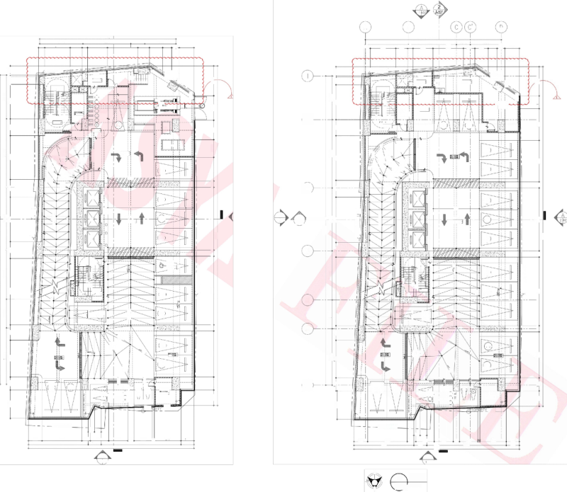
A
2 A-501
1
402
SEE SECTION.B

D
A
B
17720
17720
6250I 2600
5615 6250 I
4036
1732 1164 995 1911
1815
4036
1732 1164
1815
5615
3312 1553
95 1911
798
3963
1495
700
798 3312 1553 700 2600 3963
1495

LEGEND:
E
2198 4499 100019 1203
2103 4527 1000 166 1203
①
四 1 7 9 1
DRAWING NO.
PROPERTY LINE
PROPERTY LIN
SHEET NO.
dPRORERTY
SHEET TYPE(A/ME/PFP/S)
AUX ROOM
AUX
ROOM
dPRORERTY
N →
⑦ ⑥⑤④③②①
4 P.C.
1
◆FFL=12250MM
2527 3200 3888
o
CUTTING LINE
4143 665 3807
◆FFL=15550MW *55L=13500M
户.C.
LNE
+SSL=12200WN
D
MAICH LINE_
① ⑩ 面(8
eC
②应
⑩
5695
上 品
0
5695
页
0
疆
⑩
商
⑥
⑦
⑦ ⑥
④
.
ADMIN OFFICE
⑥
k
e
④
05
⑩
5 l ⑥.
② ②
C
EXTENSIN
GE
rdbM
4
EE ROOM
EE
ROOM
5
③②①
③②①
BICYCL 日
1
拉
7 RACK
SS=12200MM
②
09
F.E.1
10)
◆H=12100MM
SSL=12060WN
40
上
二 二
中 FFL=15400MW
55=1550MM□
3-01
4-01
FTD
中FFL=12100MM
5bL=12100WN
sLOPE
3 S I O P E
章
GSG
情s0PE
8950 800 3100 2300
RMP ro5iH40K
403
8920
博飞0PE
!
O
◆HL=11950W SSL=11950MM
00
2199 5802 2299 5722
BEN0。
1% SOPE
1900 8949 1900 5901 2199 5817
S0F
8200 5400
黄 1
1第 S.0PE
RAMP UP TO4TH FL
LN
1 SLOPE
选 5 0 M 3
1第皇OPED
(4-04)
502)
18 SOPEE
18 OPE
189.0PEC
8SL0PEL
1信SOPEE
这 复 0PE
uD
第 又QPEE
18 SOPE:
中
③
18 S0e
品
1多SOPE
o
o
4.05)
PEX
3-03
PEX
O
o
O
4150
N7
i60Do
920
920
4150
ioo
DROF- -OFF FFL=15400MM
O
8200
8200
PROPERTY
TRE POR
/ , o s
信 , o 3
岂
A
A 2402
A 2402
4-06
1
A-501
1
A-501
8
DROF-OFF
◆IL=12100WN 522100W
SEE SECTION 'A
SEE SECTION'A
2
3-04
PE
40
PE×
32=1540NN
O
40315
40315
O
44265
44265
4-07)
3-05
SEx
SEx
O
4
中
品
UP
UP
6H
3NI7
酬
营 十
1
⑤
4208
7350 3750 6400
7350 3750 6400
PROPERTY LINE
燠
恤
Q②
进 牛
④ ⑤
⑥
ROPERT
后
①
③
L 1
⑨ 凹⑫
MO bVBKIMC
6000 800 8950
⑫
400
4799 2001 8650
BLEND 10.86%
0006
4980 3d07S
o⑩
o|D
L2y
5-06

507
F.E.
F.E2
5
=3d07S
4-00
SLOPE=4%
%三OL飞F
3-12)
琴
4
BLEND=7%
SLOPE:
KEYPLAN:
6
RAMP UP FRON zD L00R
FLoo
RAMP DOW TO RD
口18 SOPE
SLOPg
sc3
4-11
0009
308
SLO
SLOPE:
SS=
006t
(4-12)
1 SLOPE
3-09)

120 Mu HGH PARA²ETL.
1400
2000 1700
004
700
. 1200 MM HIGH PARAPET
⑦
(04
司二
(3-10
414
TELCO_2
58=1850W
3-0
:
0
MOTORCYCLE
PARKING SLOT
(03
MOTORCYCLE
@
午
申 典
MDFF
◎
MOTORcYCLE PARKING SLOT
0
0
3
PARKING SLOT
TausReAN2oNAuMECHNICAL,ETC(ARCHITECTURAL.,5TRUC)SHALLTUBRoEASUL,aBECT5ANITARY,ELECTRICALFORVERIFICATIONosasecnano0s,
2000
a3
3700
3700
02 ⑬
BICYCLE( RACK
零
BICYCLE
RACK
MCTORGYCLE
PARKING SLOI.
PROF
LIE
LINE

dPROPERTYLINE
dPROPERTYLINE
805 880
05 880
DIMENSIONS. cONTRACTORS SHALLVERIFY AND BERESPONSIBLE FOR ALL DIMENSIONS
ANDcONDITONSONTHEJOB.THE DESIGNER MUSTBE NOTIFIEDIMMEDIATELY OF ANY
VARIATIONSFROMTHE DIMENSIONS AND cONDITIONS SHOWN BYTHESE DRAWING.
1772 5169 1110 2400 2490 800 2400 25 3441 710
1772
1710
1710
800
3440
5169
2400
1110 2400 2490 1685
2155
7798 1685 10358 1710
7798
10358
2155
A
A
1 401
40V
DRAWING PHASE:
s
s
WRTEN DIMENSIONS ON THESE DRAWINGSSHAL HAVE PRECEDENCE OVER SCALED
P LAN
4
FLOOR
3RD
SCALE:
LOOR
PLAN
4TH
SCALE:
2
A 303
FOR CONSTRUCTION BULLETIN
M
ASYA ASYA ASYA
3+
3 十
N
1:100 MTS
1:100 MTS
A 303
N
DATE

SHEET NO.
3RD &4TH FLOOR PLAN
A 303
TOTAL SHEETS
173
MAR 2024 GRF
ER
ER
SCALE AS SHOWNPROJ#
T T T T
T
△SYA | SEAL  REPUBLIC ACT 9266  THIS DRAWING ACTING AS AN  PRSOPEUMENToF ASYA DESYiC PARINER.  DuSsucn MEp | NOTE  WRITTEN DIMENSIONS ON THESE DRAWINGS SHALL HAVE PRECEDENCE  OVER SCALED DIMENSIONS.CONTRACTORS SHALL VERIFY AND BE  RESPONSIBLE FOR ALL DIMENSIONS AND CONDITIONS ON THE JOB.THE | DESIGNER  ALLAN C.CHUA | STRUCTURAL E  U | NGINEER  ROBERT CHRISTOPHERA.NIEBRES STRUCTURALENGINEER | SANITARY ENGINEER  JUAN CARLO NORBERTE |  | FIRE PRO ENGINEER  WI LFRED ABROGENA | ELECTRICAL ENGINEER  STEPHEN NAPEŇAS | MECHANICAL ENGINEER  WILFRED ABROGENA | PROJECT TITLE AND LOCATION  GALE RIES TOWER MANILA | LAND OWNER &DEVELOPER | SHEET  CONTENT
APLAGCE ASIA CGMPLeR,CBP-YA 72/85-05  EMAlL ADD.asyo@usyadeslgn.com.ph | SAID DOCUMENTS FOR USE IN THE REPETITION OF AND FOR OTHER  PARILECTSRIN WHDLEWTHou CHER  CONSENT.ALL DRAWINGS ARE TO BE RETURNED WHEN NO LONGER IN USE. | DESIGNER MUST BE NOTIFIED IMMEDIATELY OF ANY VARIATIONS FROM THE DIMENSIONS AND CONDITIONS SHOWN BY THESE DRAWINGS.  ANY DISCREPANCY ON ALL DRAWING &SPECIFICATIONS  (ARCHITECTURAL,STRUCTURAL,SANITARY,ELECTRICAL &MECHANICAL) SHALL BE SUBJECT FOR VERIFICATION AT THE ARCHITECT's OFFICE | ARCHITECT  REG.NO:0023165 TIN: 289-222-941  DATE: 01-03-2024 | 2302C East Tower PSE Certre,Echong od otos cco24010 a iroeqnoutoon | e  REG.NO.011903 TIN 273548-500  PTR NO.1007400 DATE 01-0424  PLACE | SANITARY  REG.NO:0002835  PTR.NO:8453437 | ENGINEER  TIN: 319-240-799  DATE: | MECHANICAL ENGINEER  REG.NO:0004781 TIN: 215-380-265  DATE: 01-03-2024 | ELECTRICAL ENGINEER  REG.NO:0004290 TIN: 242-781-694  PTR.NO:8453439 DATE: 01-03-2024 | MECHANICAL ENGINEER  REG.NO:0004781 TIN: 215-380-265  PTR.NO:8453436 DATE: 01-03-2024 | NATIVIDAD LOPEZ STREET COR.CABRAL STREET,MANILA | GRAND TAIPAN LAND DEVELOPMENT,INC. | CADD
 |  |  |  |  |  |  |  |  |  |  |  |  | CHECKED
BEFORE IMPLEMENTATION. PTR.NO:8453438 MAKATICITY 01-03-2024 PTR.NO:8453436 APPROVED

\ 192.168.2.203\production-others\Others-Galeries\05 SITE FILESI01 Site Concerns\04 Construction Bulletin\2025\02 FEB\CB01\CADFILES\3033rd &4th Floor Plan.dwg

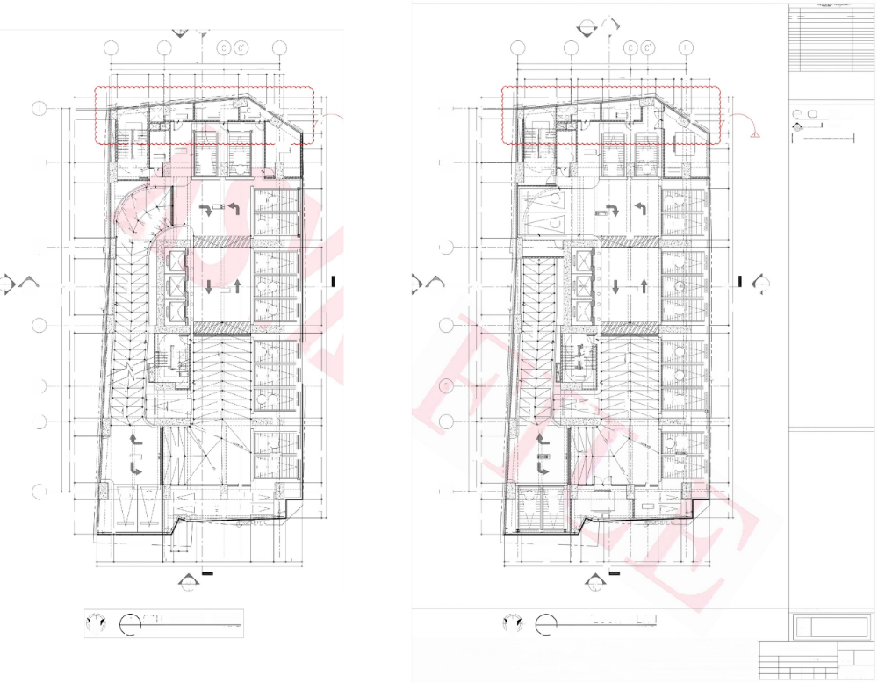
DRAWING REGISTRY
DESCRIPTION
MARK
△
DATE

DEC.10,2024
INCLINED COLUMNADJUSTMENT
2 A
2
A-501
A-501 1 402
话
A B D A B
D
17720
17720
6250 I
4036
4036
1942 803
5615
6250 1815
5615
3312 1553 700
1815
995
1031
798
2600
4578
中十
798
3312 1553 700 2600 4130 1478
1942 803 995 1911

8200 800 5400 4143 1665 1288 1848
5848 2072 4620 1203
4900 1900 8950 2199 5822 2098 4555 1000138 1203
42000
。8
¥C
29
LIN E PROPERTY
PROPERTY LINE
LEGEND:
①
四1791
吉
热o
1
STORAGE ROOM
◆HL=18700MN SSL=18700MN
STORAG ROOMi
5120M
o FR
AUX
ROOM 216
二AU×
ROOM
◆HL=18850MM SSL=18800WW
):回 日
个
u
◆FL-18650M SSL=18600MN
DRAWING NO.
C.
①
SHEET NO.
飞
000
4143 665 1293
SHEET TYPE(A/ME/P/FP/S)
BLOWER ROOM
5695
@⑤④
同③ ①⑨ ④③⑨ ①
面39
CUITTING LUNE
大
8920 5695
闻
下
大
⑩ ⑨
⑦ ⑥ ⑤ ④ ③ ② ①
MAICH LINE_
⑥ ⑥ 懊 ⑱ 0
i2②0
BBIN& ENGINEERING
OFFICE
EE ROOM
◆FFL=1850WM
◆SSL=18800MM
EE
FFL=1B70CMM
◆FHL=18700WW 中SSL=18700MM□
ROOMi
过 i @
=23050
+52=18700W
般
6-03
0
0
②
60
5-04)
品
6
②
2
②
5-=230
FE.
EE. 1
0
OMN
6-04)
十-2
◆FL=18700U
SSL-18650M

佛
1% SLOPE
条
1信aOF一
RMP后1o0nH 00R
0298
Gb (十05)
6-05)
6-32)
(6-06
FL=1855
*5SL=18550
1x50F
5400
E
3FO下
13s.OPEE
神
=22900MM
5-08) 6-0
6-0)
6-31)
6-0
第 SOPE
信 1 0FEC
z
1%SLOPEE
3
4900 1900 8950 5928 213
1830s
品
③
30
STORAGE ROOM
G10(5-09)
N 门
6-09)
PE
PE1
>
>
6-0
日

A
8200
7350 3750 6400 8200
8200
A
2 402
A
5-12( (5-11)
PROPERT
生3
PROPERT
1
A-501
DRO 中-0FF
1
A-501
DROF -OFF
SEE SECTION'A
SEE SECTION'A
PE
6-2 6-

6-5) 6-14)
2 402
401
1270
(
40315
SLOPE-14.69%
44265
40315
44265
G⁵ (5-14)
006
0 1
o s
不
>
SEx1
SE×
4
8950 300
4
品

UP
" 三4
PROPERTY LINE
JP
DM
2
2刚愉i析
⑤ (5+ 5
7350 3750 6400
03
e④⑥
24=
G-1 6-16)

6- (6-18)

6-2) 6-209)
4
② ⑤-
① ②
④ 严
SLOPE
⑥①
百
8950
帝日
51(6-18)
0.&
3
F.E.2
5=23046N
中S 9850
>
⑤
FE.2
5
3d07
= E g
脚
(5-21) 5-20)
>|
零
Gh)
6-2)
BLEND=7%
SLOPE= 4%
008 0009
BLEND=7%
S.0PE=
出
6
RAMP DOWN TO 4THL00R
RAMP DOMN To 5TH;FL0O
KEYPLAN:
神
18 SLOPE
8 S0PE
(6-23) 2
0009
5-2)
5-2
SLOPE: 4%
S⁵260DM
1 185o
◆ L- 17950MM
5SL=7950WM
6-25) 6-24)
% S03

3700 1400
00L
004L
(5-26 4
常 中 贯
第
◆FL=18150MM S2=18150
@ @
⑦
6D
6-29
6-2 6-26)
0
②
MOTORCYCLE- PARKING SLOT
◆RL=2500MM
◆SSL=22500WN
MOTORCYCLE
BLOWER
ROOM I
PARKING SLOT
2000
2000
03
3700
6-28
BICYCLE 02 RACK
3
57°
WRTENDIMENSIONSONTHESEDRAWINGSSHALHAVEPRECEDENCEOVERR HESILLAT. TM(ARCHITECTURALEaCHANICAL,ETCusReAN2oNAu,.5TRUC)SHALTURAL,BESUBJECoaosa5ANITARY,ELECTRICALTFORVERIFICATIONsecnano0s,
157级 2o
INE
NE
子
血
中
dPROPERTY LINE dPROPERTY LINE
$05 880
1772 5169 100 2400 5740 2400 1260 1710 1772 5169 1100 2400 5740 2400 1260 1710
21551 21551

A
A
1 401
1
401

S S
FLOOR PLAN
6TH
SCALE:
F L○OR
P
AN
1:100 MTS
b
SCALE:
2
A 304
3t ①
N
M
M
3 十
四N
1:100 MTS
A 304
DATE
△SYA | SEAL  REPUBLIC ACT 9266 THIS DRAWING ACTING AS AN  PRSOPEUMENToF ASYA DESYiC PARINER. DuSsucn MEp | NOTE  WRITTEN DIMENSIONS ON THESE DRAWINGS SHALL HAVE PRECEDENCE  OVER SCALED DIMENSIONS.CONTRACTORS SHALL VERIFY AND BE  RESPONSIBLE FOR ALL DIMENSIONS AND CONDITIONS ON THE JOB.THE | DESIGNER  ALLAN C.CHUA |  | STRUCTURAL E  UG uct | NGINEER  ROBERT CHRISTOPHERA.NIEBRES  STRUCTURALENGINEER | SANITARY ENGINEER  JU AN CARLO NORBERTE | FIRE PRO ENGIN  WILFRED A | EER  BROGENA |  | ELECTRICAL ENGINEER  STEPHEN NAPEŇAS | MECHANICAL ENGINEER  WILFRED ABROGENA | PROJECT TITLE AND LOCATION  GALERI ES TOWER MANILA | LAND OWNER &DEVELOPER | SHEET  CONTENT
APLAGCE ASIA CGMPLeR,CBP-YA 72/85-05  EMAlL ADD.asyo@usyadeslgn.com.ph | SAID DOCUMENTS FOR USE IN THE REPETITION OF AND FOR OTHER  PARILECTSRIN WHDLEWTHou CHER  CONSENT.ALL DRAWINGS ARE TO BE  RETURNED WHEN NO LONGER IN USE. | DESIGNER MUST BE NOTIFIED IMMEDIATELY OF ANY VARIATIONS FROM THE DIMENSIONS AND CONDITIONS SHOWN BY THESE DRAWINGS.  ANY DISCREPANCY ON ALL DRAWING &SPECIFICATIONS  (ARCHITECTURAL,STRUCTURAL,SANITARY,ELECTRICAL &MECHANICAL) SHALL BE SUBJECT FOR VERIFICATION AT THE ARCHITECT's OFFICE BEFORE IMPLEMENTATION. | REG.NO:0023165  PTR.NO:8453438 | ARCHITECT  TIN: 289-222-941  DATE: 01-03-2024 | 2302C East Tower P.SE Centre,Exchonge eodo tos cmcl2)47010 Emi Adties  ~~~  . | -  REG.NO.011903TIN 273-548-500  PLACE MAKATICITY | SANITARY ENGINEER  REG.NO:0002835 TIN: 319-240-799  PTR.NO:8453437 DATE: 01-03-2024 | MECHANICA  REG.NO:0004781  PTR.NO:8453436 | L ENGINEER |  | ELECTRICAL ENGINEER  REG.NO:0004290 TIN: 242-781-694  PTR.NO:8453439 DATE: 01-03-2024 | MECHANICAL ENGINEER  REG.NO:0004781 TIN: 215-380-265  PTR.NO:8453436 DATE: 01-03-2024 | NATIVIDAD LOPEZ STREET COR.CABRAL STREET,MANILA | GRAND TAIPAN LAND DEVELOPMENT,INC. | CADD
 |  |  |  |  |  |  |  |  | TIN:  DATE: | 215-380-265  01-03-2024
 |  |  |  |  |  |  |  |  |  |  |  |  |  |  | CHECKED

MAR 2024
GRF
ER
ER

DRAWING PHASE:
FOR
ASYA ASYA
ASYA

5TH &6TH FLOOR PLAN
SCALE AS SHOWN PROJ#
T T T T

CONSTRUCTION BULLETIN

SHEET NO.
A 304
TOTAL SHEETS
T
173

APPROVED

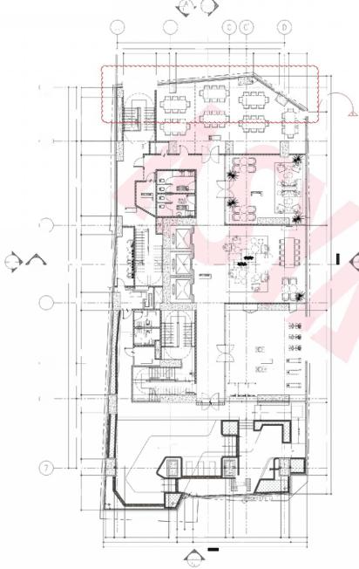
WRTENDIMENSIONSONTHESEDRAWINGSSHALHAVEPRECEDENCEOVERLLAT.SY TM(ARCHITECTURAECHNICAL,ETCausReAN2oNAuL.,5TRUC)SHALLTURAL,BESUBECToaosa5ANITARY,ELECTRICALFORVERIFICATIONsecnano0s,
SEESECTION8
8920 5695
6434 1486 4649
型别
3807
7420 4588
40315
3750 6400 8200
8950 1900 6100 20
ROPERT
4
三
号告
年
告告
PROPERTY LINE
0006
9750
44265
此==二
7350
4900
7700
3700 1400
2000
s
1 7
N
A 305 SCALE:
N
PL AN 1:100 M
LOOR
F
M
3
2
402 A-501

B
17720
6250 I
700 8208

4.

③
飞

FUNCTION/MEETING RO0M
(VERIFY INTERIOIR)
L=29600MM
5L=29550WN
◆HL=29600WM 5Q=29550MM
F.E.1

FEOMAELE
CO-WORKING
52=29550M

2050
FHL=29600NM ◆5SL=29550MM

UP
② ③
PEX
.0
2-
Fi2_
uPdJ
RESIDENT'S
LOUNGE
PEX
摄
+SS=29550M

SEX₁
中FFL=29600WN
552=29550NW
EE
4
中
MALE
HANGiNG

中 FL=29450WM
EMALE HAN NGING
OLE
二 空 7 克
FITNESS GYM
◆FL=29600W
S-29550MM□
空
F.E.
◆ 册 2 9 6 0 0
中SL=29550N ②
国
和
6
8%SLOPE

POOL
(VERIFY LANDSCAPE)
on

36
TAN形
157
INE

dPROPERTY LINE
805 880
800
1685
2155
A
1
00014
列望⑥药图
N 二
④9⑥
3鱼鱼页应鱼43
③立逐西霞0应②
A
5615
3462 1403
1815 4036
95
中 798
2745
1911
peoPERTYLIN
①

②
4
dROREF
五 图
④ DN
JANITOR ROOM
AUX ROOM
◆SSL=29700MM
3
_
⑤ 面
3-
i4_ 画
A
2402
A
① _
②
1
A-501
SEE SECTION'A
2
r AUX
ELEVATOR LOBBY
⑭20_
_
40V
P
ROOM
26o
SS=29400M
DN
PUMP ROOM 中FL=29400W
◆SSL=29350MM
⑤
古
①
⑥⑤
(VER/FY LANDSCAPE)
900 115
800
900
5050
1860
1710
5200
4690
7798
10358
401

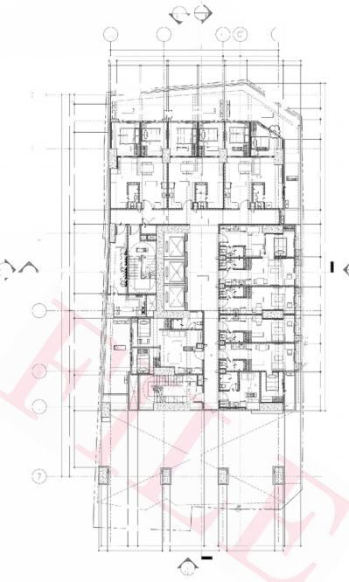
SEE SECTION8
40315
3750 6400 8200 8920 5695
3750 5999 2601 7350 1500 8200 2963
PROPERT
N7
ALLWAY
OPER
4075 3000 3000 3000 3150 3475 1500 7451 2103 1152
34565
7350
0009
A
240
A
402

B
17720
5615
5297
2723

①
DECK
GARDEN DECK FL=3450WM
◆55L=34400MW

BEDROOM 1
MASTER'S BEDROOM
BDRo
②
DIIN LIVING
UNIT
BR
◆FFL=34600WM
SS=34550MM

KITCHEN
义
wm

DECK
◆fL=34600MM
55L34550WN
GHA
E===
UNIT G 1-BR
.E
SS=34
① 2.
P GQxES
1 SEE SECTION'A A-501
圆
JNIT I
iuiui
SEX1
EE RQOM
◆FHL=34700WN
4
wM
圆
8
UNIT J STUDIO
5234650M
5 DECK
UNT-s= 2-BR 1二2_
UNIT K
STUDIO
==
5
◎
50M
do
6

ORENT0 BELOW

ROPERTY LINE
中VE

PROPERTYLINE

1500
5200

A
1 401
PROPERTY LINE
DECK
◆F=34450WN GARPEN pEck ◆SS-34400MM
LVING
NITA-B 2-BR
③
A
2402
ELEVATOR LOBBY
513450
2
A-501
D
UNIT C-D 2-BR
UNIT H STUDIO
7000
5050
1860
1860
UNT BR
◆FH=34600MN 55=34550MV
0 枢
中FFL=34600WN 52=34550M
◆H=34450MM
◆SSL=34400MM
GARpEN QECK
dLINE oFL 原LDING ABI
鼻象 园
HAL LWAY
PROPERKY
DECK
FFL=34450MM
◎
◎
④ ⑤ G ⑦
6250
⑥
798
谓二
e3650
⑥⑥
365
800
800
STUDIO
网⑧
S9-34850M
KITCHEN
KITCHEN
◎
◎
◎
DINING
懊
6
2793
4036
2245
3832
5805
1815
1050
2848
6077
7000
回 图
5891
3194
AUx
3221
1710
DINING
340N
露
EN
LIVING
900
900
A
wM
圆
图
DECH
RP
SS5=34550MM
图 ]
000
PE
WM
⑩
E.
级
圆
PE
C
O
3
I
A
-

 | DRAWING REGISTRY
 | MARK |  | DESCRIPTION |  |  |  | DATE
 | △ |  | INCLINEDCOLUMN ADJUSTMENT |  |  |  | DEC.10,2024
 | LEGEND:
① DRAWING NO.
四1791 SHEET NO.
SHEET TYPE(A/ME/PFP/S)
CUTTING LINE

MAICH LINE_
 | KEYPLAN:
 | DRAWING PHASE:
 |  | ASYA  ASYA  ASYA |  | FOR CONSTRUCTION BULLETIN
7TH &8TH FLOOR PLAN |  |  |  |  |  | SHEET NO.
 |  |  |  |  |  | A | 305
SCALE AS SHOWN |  |  |  | PROJ# |  | A
TOTAL SHEETS
173
T | T |  | T | T | T

DATE
MAR 2024 GRF
ER
ER
S
FL○OR
3十
SCALE:
A 305
N
D AN
1:100 M
2
M

△SYA | SEAL  REPUBLIC ACT 9266  THIS DRAWING ACTING AS AN  PRSOPEUMENToF ASYA DESYiC PARINER.  DuSsucn MEp | NOTE  WRITTEN DIMENSIONS ON THESE DRAWINGS SHALL HAVE PRECEDENCE OVER SCALED DIMENSIONS.CONTRACTORS SHALL VERIFY AND BE  RESPONSIBLE FOR ALL DIMENSIONS AND CONDITIONS ON THE JOB.THE | DESIGNER  ALLAN C.CHUA | STRUCTURAL  L | E  UC | NGINEER  ROBERT CHRISTOPHERA.NIEBRES STRUCTURALENGINEER | SANITARY ENGINEER  JU AN CARLO NORBERTE | F IRE PRO ENGIN  WILFRED A | EER  BROGENA |  | ELECTRICAL ENGINEER  STEPHEN NAPEŇAS | MECHANICAL ENGINEER  WILFRED ABROGENA | PROJECT TITLE AND LOCATION  GALERIES TOWER MANILA | LAND OWNER &DEVELOPER | SHEET  CONTENT
APLAGCE ASIA CGMPLeR,CBP-YA 72/85-05  EMAlL ADD.asyo@usyadeslgn.com.ph | SAID DOCUMENTS FOR USE IN THE  REPETITION OF AND FOR OTHER  PARILECTSRIN WHDLEWTHou CHER  CONSENT.ALL DRAWINGS ARE TO BE  RETURNED WHEN NO LONGER IN USE. | DESIGNER MUST BE NOTIFIED IMMEDIATELY OF ANY VARIATIONS FROM THE DIMENSIONS AND CONDITIONS SHOWN BY THESE DRAWINGS.  ANY DISCREPANCY ON ALL DRAWING &SPECIFICATIONS  (ARCHITECTURAL,STRUCTURAL,SANITARY,ELECTRICAL &MECHANICAL) SHALL BE SUBJECT FOR VERIFICATION AT THE ARCHITECT's OFFICE BEFORE IMPLEMENTATION. | ARCHITECT  REG.NO:0023165 TIN: 289-222-941  PTR.NO:8453438 DATE: 01-03-2024 | 2302C East Tower PSE Certre,Echong od otos cco24010 a iroeqnoutoon |  | e  REG.NO.011903 TIN 273548-500 PTR NO.1007400 DATE 01-0424  PLACE MAKATICITY | SANITARY ENGINEER  REG.NO:0002835 TIN: 319-240-799  PTR.NO:8453437 DATE: 01-03-2024 | MECHANICA REG.NO:0004781  PTR.NO:8453436 | L ENGINEER  215-380-265 |  | ELECTRICAL ENGINEER  REG.NO:0004290 TIN: 242-781-694  PTR.NO:8453439 DATE: 01-03-2024 | MECHANICAL ENGINEER  REG.NO:0004781 TIN: 215-380-265  PTR.NO:8453436 DATE: 01-03-2024 | NATIVIDAD LOPEZ STREET COR.CABRAL STREET,MANILA | GRAND TAIPAN LAND DEVELOPMENT,INC. | CADD
 |  |  |  |  |  |  |  |  |  |  |  |  |  |  | CHECKED APPROVE
 |  |  |  |  |  |  |  |  | TIN:  DATE: | 01-03-2024
D

I 192.168.2.203\production-others\Others-Galeries\05 SITE FILES\01 Site Concerns\04 Construction Bulletin\2025\02 FEB\CB01\CADFILES\3057th Floor &8th Floor Plan.dwg

